Rocky Lake Elementary School
School Newsletter
April, 2023
Principal: Vince MacNeil Vice-Principal: Courtney Smith
Follow us on Twitter: @RockyElementary or on our website: https://rle.hrce.ca
________________________________________________________________________

School Safety
Recently, Ms. Smith and I met with Constable Desrochers, our Community Police Liasson Officer. Cst. Desrochers will be stopping by occasionally and may do some programming around topics such as Bullying and Internet Safety in some of our classrooms. We look forward to seeing him at Rocky Lake Elementary over the coming months!
School Equity Team
We have established a School Equity Team to encourage greater acceptance of the diversity in our school. Our school Equity Team has already started working with students. Parents and guardians will receive a letter from the Equity Team shortly.

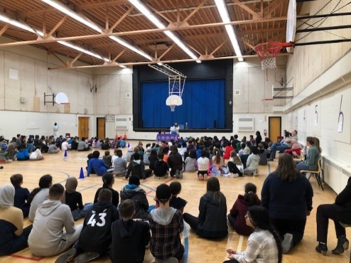
Mad Science
Our first school assembly was a huge success! Mad Science put on a great show for our students and they were well behaved! Registration for lunch time Mad Science classes closes on April 7, 2023. Click on the link below to register your child. At this point, space may be limited.
Rocky Lake Mad Science Registration

Rocky Lake Elementary – Community Square Dance – Friday, May 6th
Earlier in the year we applied for a grant through Perform and secured a dance instructor who was to teach the students how to Bhangra Dance. We had to change performers due to a scheduling issue. We booked another dance teacher, Colleen Putt, to come instead.
During the month of April, Ms. Putt will be working with Ms. Hardy and Mr. Mahaney to teach the students to Square Dance. Students are going to learn to do the Inverness Set. Additionally, pupils will learn to perform a traditional Nova Scotian Milling Frolic with Ms. Hardy. Students will also receive Gaelic language and cultural programming based on curriculum outcomes from Ms. MacEachen (Gaelic teacher at Citadel High).
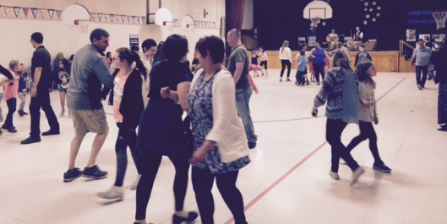
We hope to culminate this project with a Community Square Dance on Friday, May 6th in the school gym. Students who are interested in attending, will come with their families. Parents, guardians and family members will be encouraged to join in.
Colleen Putt will be our square set caller and she will be joined by Skip Jones and Joseph Pratt (shown left). We may feature a milling frolic during the intermission. This will mark the beginning of Gaelic Month in Nova Scotia. The Gaels are one of the four emphasized groups in the Nova Scotian curriculum. Our project is also supported by the Office of Gaelic Affairs, a division of the Provincial Government. Please consider supporting this community building initiative by joining our square dance!
Broad Street School
The soon to be named Broad Street School does not require any registration forms from students who are currently attending Rocky Lake Elementary and who are in the catchment area for that school. Your child will be “pointed” to the school in PowerSchool.
Up-coming Dates
No School –
Friday, April 7th Good Friday
Monday, April 10th Easter Monday
Have a great holiday weekend!!!

